UMCP Conceptual Framework

- Knowledge of Subject Matter
- Knowledge of Curriculum
- Knowledge of Learners
- Knowledge of Educational Goals and Assessment
- Knowledge of Social and Cultural Context
- Knowledge of Pedagogy
- Reflective Practitioners

University of Maryland NCATE ¹ Conceptual Framework
The College of Education at the University of Maryland prepares reflective practitioners for a diverse society through research based professional programs. Our shared vision is consistent with our mission as a Research I institution that views Research and Inquiry, Diversity, Collaboration, and Technology as foundations to our
conceptual framework (see Figure 1 below).

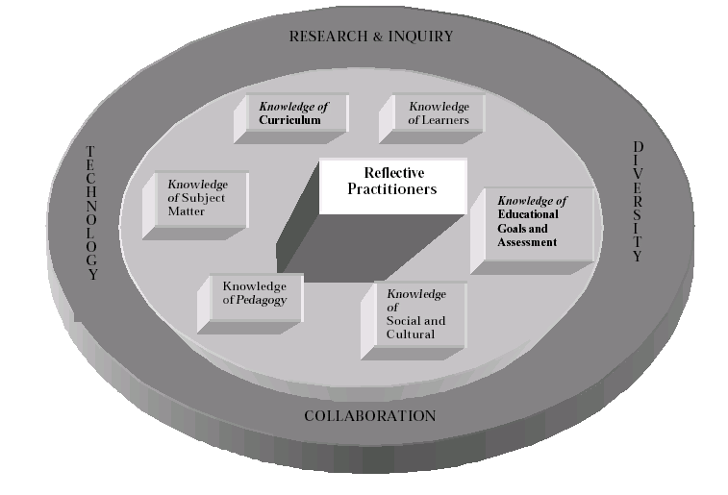
1 National Council for Accreditation of Teacher Education

The performance based educational programs at the University of Maryland are grounded by a research-based conceptual framework and are guided by a set of
performance standards that identify what all educators should know and be able to do. Seasoned educators and teacher candidates entering their yearlong internship, experience a foundation of knowledge in the following areas: the learner, educational goals and assessment, subject matter, curriculum, pedagogy, social context and reflective/disciplined inquiry. The information, dispositions, and skills associated with these domains are acquired through coursework as well as clinical experiences. Together these provide the conceptual framework for teaching and learning. The conceptual framework is grounded in the belief that educators need to draw upon many types of knowledge when they are making decisions about teaching and learning. Performance standards identify the behaviors that correlate with each area in the conceptual framework. The work of the Interstate New Teachers Assessment Support Consortium (INTASC) provides the basis for these standards.

